We have two account one with email soli@google.com and one with doli@google.com
both password is soli

Let’s start with xss :

I found one in the message functionality wish is the easy way to perform xss in any user just by sending a message and waiting till he open it
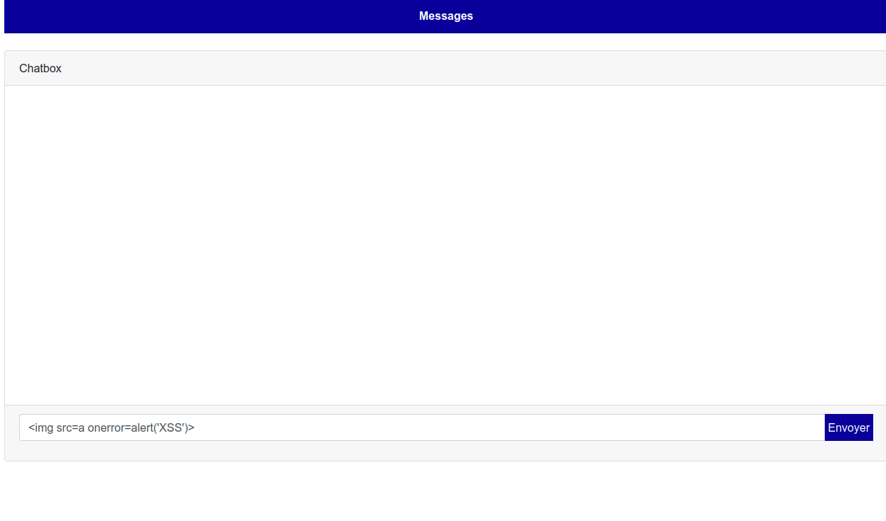

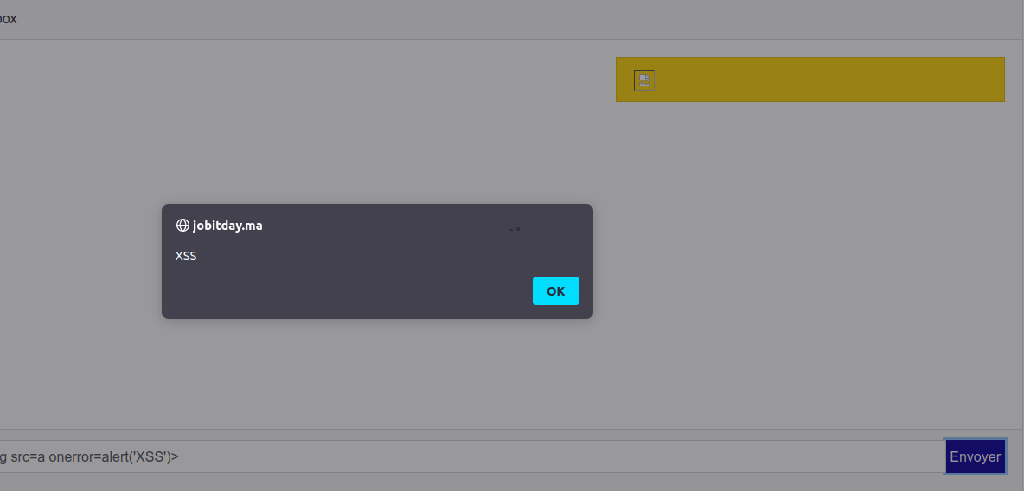
so let’s verify with the other account

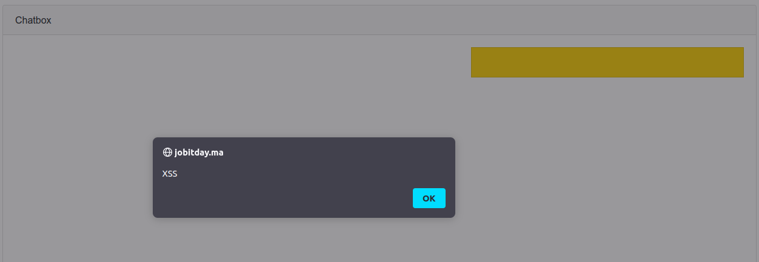
it works

Parameter tampering
The second one is more severe wish is changing the request

this is the page that we will be attacking : https://jobitday.ma/StudentProfilEdit
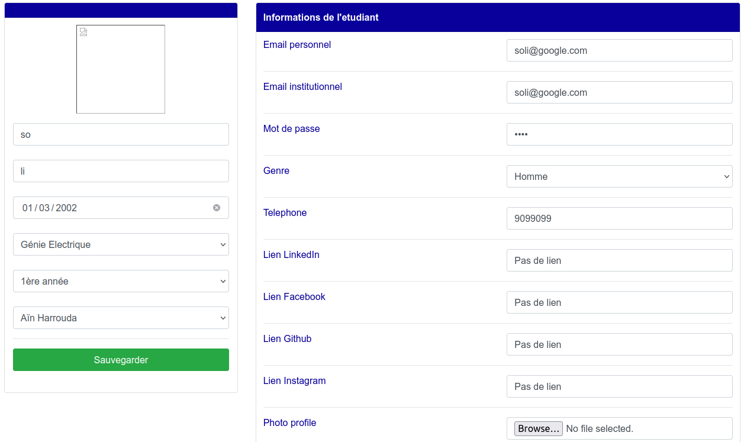
what I will do : I will change my credentials but instead of affecting myself I will chose the account that I would like to change his credentials wish mean I can access his account

so when we send this request with burpsuite we can see

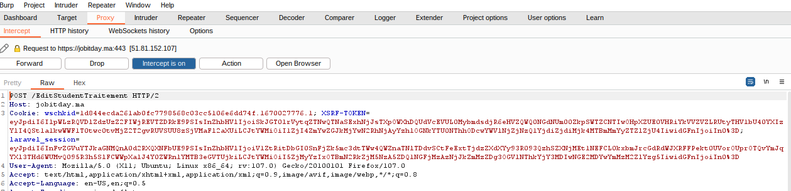
post request with a bunch of parameter in the body
the most important one is id

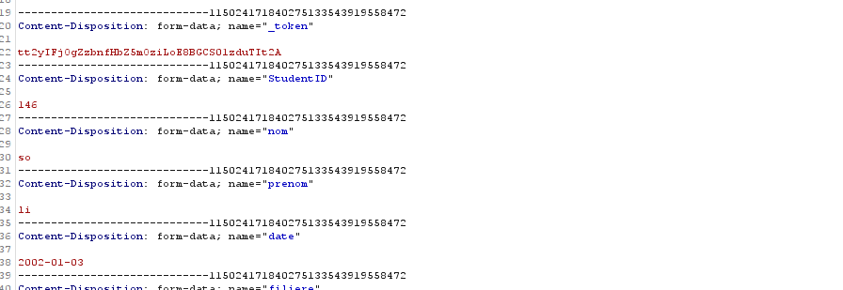
when we change the id of the user we can affect the other user

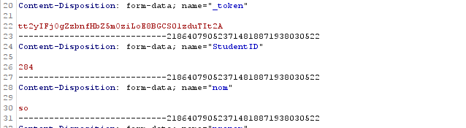
this is the id of the user that I want to affect wish is my other account I will not harm any one

and it works I can now login with the new password

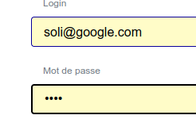

this is another story where I can use any password size that I want

so what I can do with this attack is to change all the users credentials so no more information in the db
or I can find a specific id and change the info

Excessive data exposure
In this section we will get all passwords

this is the page that we will be attacking : https://jobitday.ma/AllStudents
it display all users in a specific sector
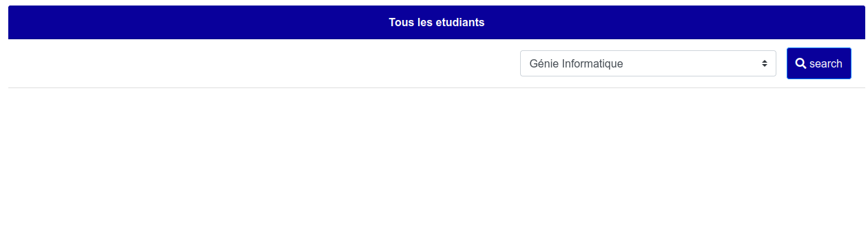
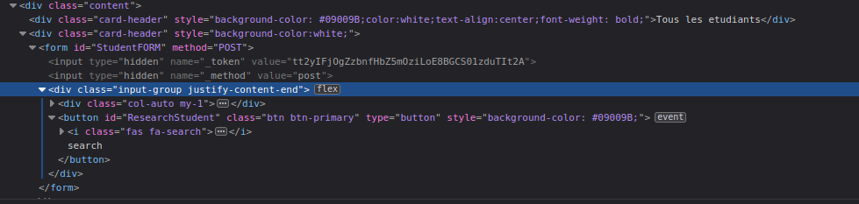
so when we click on the button what happen
→ all the accounts get displayed
the first question is that how ?
The answer is ajax code
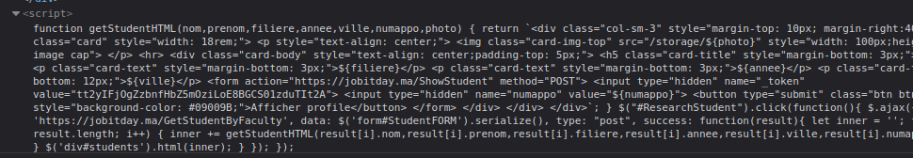
we need to get a more clear look

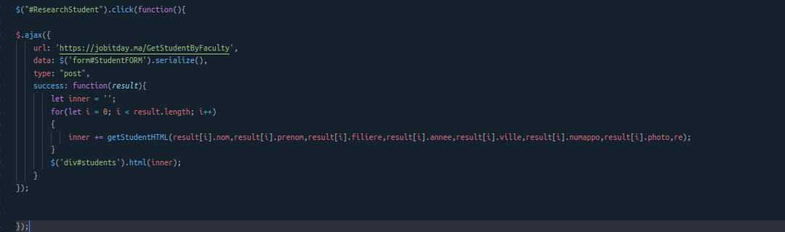
what we can see here is that when we click the button we send a post request and we will have as result an object result wish contain some fields like prenom nom …
so what I want to do ,is to look what does this object contain else there is any id or emails or password emmmm
I’ve used the browser debugger to find out
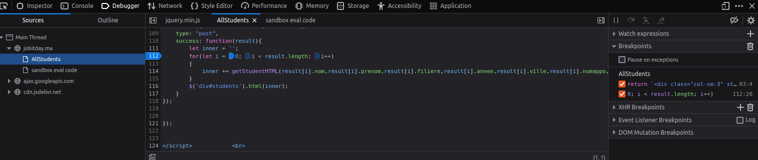
so now let’s refresh the page and let have a look at our result
we click on search and :
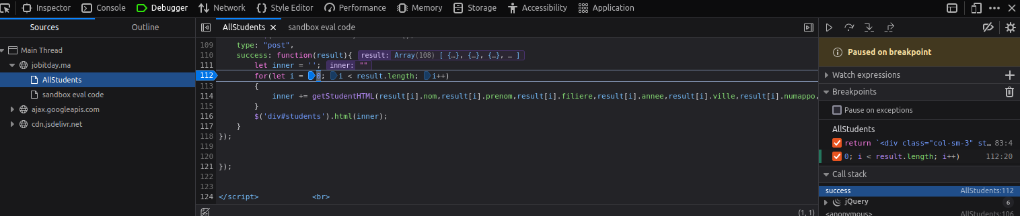
we can see the object here ok let’s see what we can find inside it
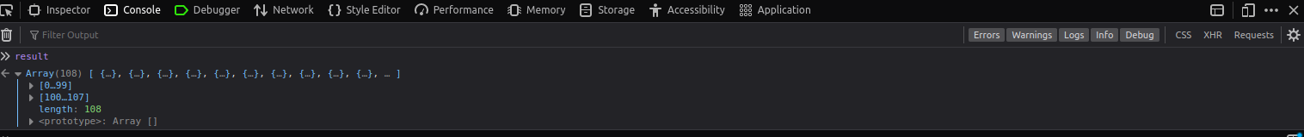
and the biggest present is :
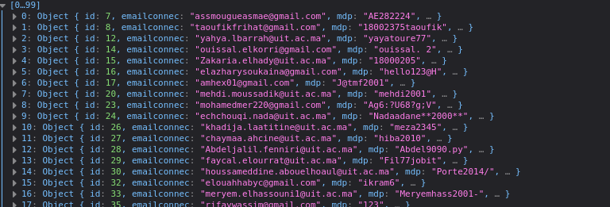
all emails and passwords
also we can see more information about any one of them

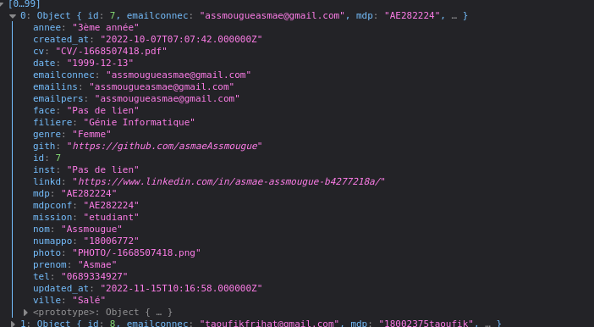
so now we can take this information and try it in other website

